Name of the Topic: Report Outline

Submitted in partial fulfilment of the requirements
of the degree of
M. Tech. in Technology and Development

By
Name of Author
Roll No.

Supervisor
Prof. Name

Centre for Technology Alternatives for Rural Areas (CTARA)
Indian Institute of Technology Bombay

Month YYYY

Dedication
To all Ctrl+C and CTRL+V ers out there!
Here is an automated format of IIT Bombay report style, based on the official “Guidelines for Preparation of Theses/ Dissertations/ Reports” (Academic office, 2009) document.
For all the heading levels, their spacing, fonts, numbering, nested level, etc. have been set. In chapter one, at each heading level, corresponding heading number in styles is given at the first instance of use. Similarly, for captions (tables, figures, etc.) everything has been set, including their alignment, spacing, etc. So, from the Styles on the home tab in the ribbon in MS Word, select the appropriate style required for your text.
Table of contents, tables, figures, etc. have been automated but will be useful only if you remember to use automated captions while labelling the same. For this, use insert caption tab under references tab on the MS word ribbon.
The page breaks have been set with a mind for need of odd – even pages while printing both sided. If you plan to print one sided, few extra blank pages might get introduced. Use page breaks as often as possible to ensure that the text you want on the same page, stays on same page. But to keep headings and such with the following text, use the “keep with next” feature in the line and page breaks section of paragraph tab on home tab in the ribbon.
The more you automate the report while writing, the less efforts you need to edit, format and get the report in final printable stage. Feel free to adopt this report for your purpose.
Under the creative licenses, i proclaim this work (an original work by me, but by no means unique, as ideally every other student in IIT Bombay must have used almost the same styles for their thesis reports) to be under the Public domain waiver (CC0) but if you so feel, please do attribute this report outline to me somewhere in the acknowledgements of your report.
Thanks!

Dissertation Approval
This is to certify that the M. Tech. Dissertation report titled “Name of the Topic: Report Outline” by Name of Author (Roll No.) is approved for the degree of M. Tech. in Technology and Development.

Name
(External Examiner)

Name
(Internal Examiner)

Name
(Guide)

Name
(Chairperson)

Date:
Place: Mumbai

Declaration
I declare that this written submission represents my ideas in my own words and where other’s ideas or words have been included, I have adequately cited and referenced the original sources. I also declare that I have adhered to all principles of academic honestly and integrity and have not misrepresented or fabricated or falsified any ideas, data, facts or sources in my submission. I understand that any violation of the above will be cause of disciplinary action by the institute and evoke penal action from the sources which have thus not been properly cited or from whom proper permission has not been taken when needed.

Date:
Place:

Name of Author
Roll No.

Abstract
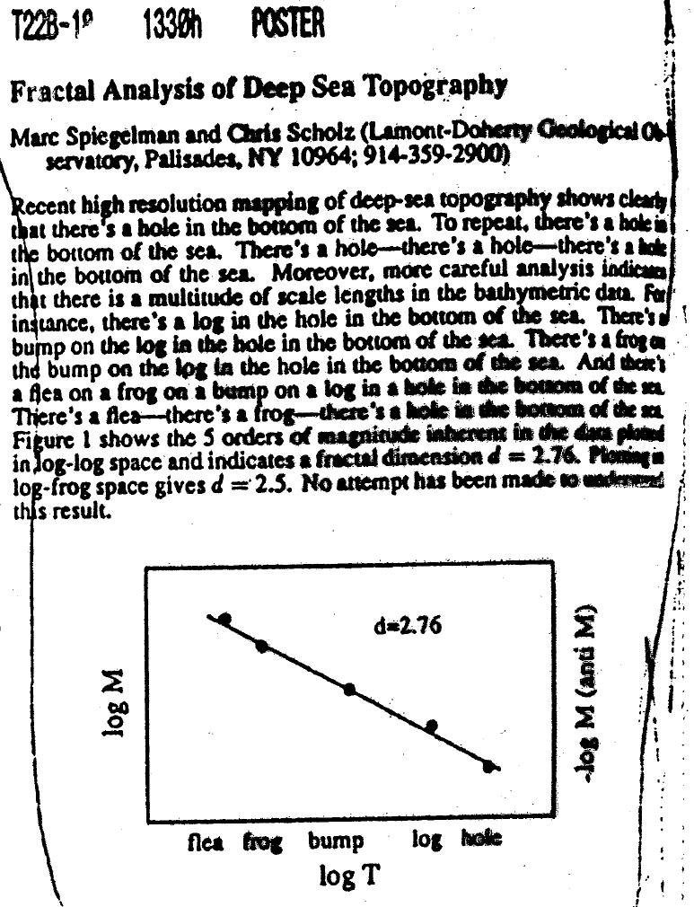
http://geologicfroth.com/deeply-insightful-abstract

Table of Contents
Contents
Dedication i
Dissertation Approval iii
Declaration v
Abstract vii
Table of Contents ix
List of Figures x
List of Tables x
List of Graphs x
List of Appendices x
Nomenclature xiii
Chapter 1 Title, style Heading 1 1
1.1 Title Case Level One heading, style Heading 2 1
1.1.1 Lower case level two heading, style Heading 3 1
1.2 Structure of Report 2
Chapter 2 Chapter Two 5
2.1 Is the Scientific Paper a Fraud? 5
2.2 Inserting Footnotes 5
2.2.1 Use of technical language 5
2.2.2 Referencing 6
Chapter 3 Chapter Three 7
3.1 One 7
3.1.1 One point one 7
Chapter 4 Title 9
Chapter 5 Conclusion 11
Appendix 13
References 15
Acknowledgements 17

List of Figures
Figure 1.1: Caption 2

List of Tables
Table 1.1: Caption 2

List of Graphs
Graph 3-1 1

List of Appendices
Appendix I 1
Appendix II 1

Nomenclature

Title, Style Heading 1

Title Case Level One Heading, Style - Heading 2
Tell what you are going to tell in the introduction. Then in tell what you want to tell. Then sum up what you told and connect to what will be next (tell what you will be telling after this). Follow this advice in every chapter, every section as well and you will create a wonderful document. Though, you can skip it in favour of brevity and if you already have a nice clarity.

Lower case level two heading, style - Heading 3
Hypothesis non fingo – Issac Newton in Principia, 1713
I have not as yet been able to discover the reason for these properties of gravity from phenomena, and I do not feign hypotheses. For whatever is not deduced from the phenomena must be called a hypothesis; and hypotheses, whether metaphysical or physical, or based on occult qualities, or mechanical, have no place in experimental philosophy. In this philosophy particular propositions are inferred from the phenomena, and afterwards rendered general by induction.
http://en.wikipedia.org/wiki/Hypotheses_non_fingo

Level three heading, style Heading 4

Table 1.1: Automated Caption using Insert caption in Reference tab
Heading row
As per your preference, remove space after paragraph for table to compress the lines used in the table.

Figure 1.1: Automated Caption

Structure of Report
Chapter 1 Introduction – contains background, motivation, broad societal concern to main objective, context of problem, Structure of Report
Chapter 2 Literature review – review of literature including background, basic info about the sector/ topic being researched, methods being used, geographies being explored, any other topical literature. This can also propose literature/ research gaps.
Chapter 3 – Research Methodology – contains short note the methodology of the research – Quant/ qual, mixed, ontology, epistemology. Followed by research questions, objectives, sub research questions, tasks, sub tasks, methods for each SRQ, etc. as preferred by your guide. Continue with scope of your study and important boundaries that you have set at the beginning.
Chapter 4 – Results – based on your methods, the outputs of your tasks go here. Arranged sequentially as per your RQs, this can be broken into more chapters as needed and appropriately titled.
Chapter 5 – Discussions – discusses results and findings using existing literature, your insights from other sources, views. Here you try to triangulate/ vet your results.
Chapter 6 – Conclusions – includes summary of your results, records how you have addressed all the research questions and completed your work, gives limitations of the current study, has a section on future work.
Details of what should go in each section is described in the guidelines (Academic office, 2009) and by your guides as well, so follow them if any conflict with what i have proposed.

Chapter Two

Is the Scientific Paper a Fraud?
http://contanatura-hemeroteca.weblog.com.pt/arquivo/medawar_paper_fraud.pdf
This article explains the logic of scientific process and how it should proceed; also, how a scientific communication should be written actually, which is different than what you are supposed to be writing right now

Inserting Footnotes
Follow these steps
- Take cursor after the word where you want to footnote marker to be displayed
- Click on References, the fifth tab (after File, Home, Insert and Page Layout)
- Click on Insert footnote
- Now type your footnote at the bottom of the page where the cursor goes automatically. You can easily edit this as per your need, later on.

Use of technical language
https://eng.kuleuven.be/prev/english/education/reporting/language-style
http://www.sussex.ac.uk/ei/internal/forstudents/engineeringdesign/studyguides/techreportwriting
both these are supporting informations, if they clash with what IITB guidelines or your guides say, ignore them. But these are good, standard rules to a great extent

Referencing
Try to reference every comment you make that is not your own. Using APA style,
https://apastyle.apa.org/
you can practically cite any source, including twitter, youtube, etc. it is up to you to confirm veracity, quality of the source.
Based on your discipline, you might use IEEE, Chicago and other styles. Most of these can be automated within word or using citations manager such as Mendeley.

Chapter Three

One

One point one

Graph 3-1
(Diwakar, 2011)

Title

Conclusion
Once the report is done, it’s time to take the enquiry further.
Will IITB ever consider using other fonts than the Times New Roman in report submissions? Does anyone actually check if all the details of styles are followed in the documents submitted? Where can we access past reports, search through them, like we search for journals?

Appendix
Appendix I
Number one

Appendix II
Number two

References
Academic office. (2009, June 17). Retrieved October 2016, from IIT Bombay, Powai: http://www.iitb.ac.in/newacadhome/rules/Dissertation17june09-10.pdf
Diwakar, Y. R. (2011). Report Outline. Mumbai: IITB.

Acknowledgements
Who should I thank? My so-called ``colleagues,'' who laugh at me behind my back, all the while becoming famous on my work? My worthless graduate students, whose computer skills appear to be limited to downloading bitmaps off of netnews? My parents, who are still waiting for me to quit ``fooling around with computers,'' go to med school, and become a radiologist? My department chairman, a manager who gives one new insight into and sympathy for disgruntled postal workers?
My God, no one could blame me -- no one! -- if I went off the edge and just lost it completely one day. I couldn't get through the day as it is without the Prozac and Jack Daniels I keep on the shelf, behind my Tops-20 JSYS manuals. I start getting the shakes real bad around 10am, right before my advisor meetings. A 10 oz. Jack 'n Zac helps me get through the meetings without one of my students winding up with his severed head in a bowling-ball bag. They look at me funny; they think I twitch a lot. I'm not twitching. I'm controlling my impulse to snag my 9mm Sig-Sauer out from my day-pack and make a few strong points about the quality of undergraduate education in Amerika.
If I thought anyone cared, if I thought anyone would even be reading this, I'd probably make an effort to keep up appearances until the last possible moment. But no one does, and no one will. So I can pretty much say exactly what I think.
Oh, yes, the acknowledgements. I think not. I did it. I did it all, by myself.
Olin Shivers
Cambridge
September 4, 1994

(http://www.scsh.net/docu/html/man.html )

This is the footnote, while that superscript 1 is the footnote marker.

