**Laboratory 1  
Introduction to Opamps**

**Q0**: /2 **Q1**: /2 **Q2**: /3 **Q3**: /3 **Tot:** /10

**Objective:**

In this assignment we will introduce you to the simple LM741 opamp IC. You will learn how to reliably make connections and build circuits around this IC. We will use the LM741 for many experiments during the rest of the semester, so please make sure that at the end of this lab, you are thoroughly familiar with making circuit connections to the LM741

**LM741 as a voltage comparator and its characteristics**

Fig 1 shows a picture and the pin diagram of the LM741

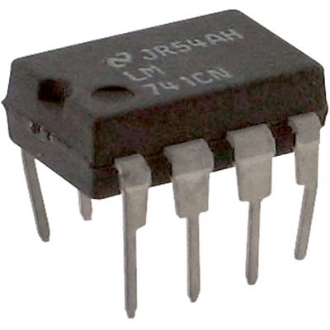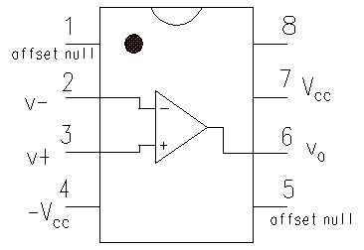

Fig 1: Picture and pinout of LM741

Note the numbering of pins as viewed from the top, with the semicircular notch facing up. You must always remember this when connecting the IC on a breadboard as shown in Fig 2

Fig 2: Connecting the LM741 on a breadboard

**WRONG !** Pins 1-4 and 5-8 are shorted to each other

**CORRECT:** Each pin has a separate breadboard trace. +VCC and –VCC are  
connected along the edge traces

+VCC

-VCC

**Note:** two halves of the edge trace do not have a connection. You can use them separately, or jumper together

Connect up an LM741 as shown in Fig 2 (correctly!) Apply +12V and -12V as the +VCC and -VCC to power the IC. The COM=(+VCC – VCC)/2 = 0 terminal from the power supply provides a zero reference voltage for other components in your circuit. You can connect it to one of the edge traces of your breadboard.

Fig 3 shows the functional block diagram of the 741. The general equation governing the behavior of this circuit is VO = G(V+ - V-) where V+ and V- are the voltages at the two input terminals of the opamp, and G is a very large open-loop gain factor ~ 106. For today’s exercise, we would like to use this functionality to compare a square wave *single-ended* signal Vin to a reference DC voltage Vref. Every time Vin rises above a preset Vref, VO should immediately go to the maximum allowed value. You can use the function generator to provide V­in and one of the benchtop supply outputs to set Vref.

Be sure to make a note in the following diagram of the signal and ground connections of the single ended input V­in you are applying from the front panel of the function generator. Also mark all the signal and ground connections for Vref and Vout

Vin

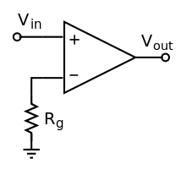

Vout

VrefVin

time

?

Fig 3: Use LM741 to compare a changing Vin to a fixed reference Vref .  
 **Question 0:** Mark in the left diagram your signal and ground connections.

Vref

+VCC

-VCC

For now leave the two offset null pins unconnected (we will learn their use later)

**Question 1:** Observe and note the time traces of Vout and Vin in the figure above.

**Question 2:** You will note that Vout changes state with a slight time lag after Vin exceeds Vref. Look through the LM741 datasheet to determine if this lag matches the specified value. (It is technically called the slew rate)  
 How does the slope of Vout change as you change the frequency of Vin?  
  
 Does it change for different values of Vref?  
**Question 3:**  Now *disconnect* Vref and make a connection from the output Vout to V- (keeping Vin connected to V+ as before). You have now ‘closed the loop’ and made a feedback circuit around the opamp. Repeat the observations of Question 1 above. Using the opamp equation Vout = G(V+ - V-) above, work out the relation between Vout and Vin Are your observations in agreement with this relation? Voila! this is the simplest *negative*feedback circuit you can make with an opamp – we will see many more later.