**Laboratory 2  
Positive feedback – Schmitt Trigger**

**A**: /2calc+1demo **B** : /3calc+2demo **C**: /3calc+3demo **Tot:** /15

**Introduction**

In today’s lab we will introduce the concept of *positive feedback* in opamp circuits. As we learned in Lab 1, the open loop gain of an opamp is ~ 106 and the maximum output swing is between +Vmax and   
–Vmax (with a time lag of ~ tens of microseconds determined by the slew rate).  
This implies that with simple open loop operation the input range of the opamp (v+ - v-) would be restricted to ~ μV range. *In practice*, the opamp is never used in the open-loop configuration: a small fraction of the output is fed back to one of the inputs to improve the gain and stability of the circuit.

**Revision of Lab 1**

Fig 1 shows the simple comparator circuit that we tested in Lab 1 to determine the slew rate of the LM741. We used a square wave input in Lab 1, a clean sine wave input is shown in Fig 1

VT

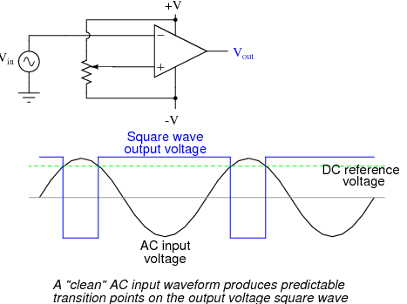

Fig 1: Voltage at V+ terminal sets the VT DC threshold.   
As long as Vin stays less than VT, Vout = +Vmax  
When Vin > VT , Vout swings to –Vmax

VT

A “clean” Vin produces predictable transitions of Vout

+

Vout goes to -Vmax reliably when Vin > VT

**Objective of today’s Lab 2**  
Consider an application where Vin is created by a light sensor. Your circuit output should stay fixed (at +Vmax or -Vmax)as long as the light level stays inside a pre-defined band. It should switch only when Vin goes outside the threshold band. Since the light level signal is highly variable, the Vin to your circuit of Fig 1 would look approximately like that shown in Fig 2. If the simple comparator is used the alarm will annoyingly go off many times as the noisy Vin crosses VT

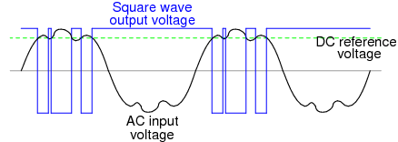

Fig 2: A noisy Vin hovering around the threshold VT causes Vout to switch many times.

Vout switches unreliably as Vin hovers around VT

VT

**Part A: Create a noisy Vin**

Setup an LDR (a Light Dependent Resistor) as a light sensor with a +5V power supply and a calculated value of series resistor to produce a signal around +3.5V. Check the output of your light sensor using a multimeter – its output should vary as you cover it with your hands or a piece of paper. You should also be able to observe the noise caused by ambient tubelight at 60 Hz frequency by observing this signal trace on the DSO.



+5V

LDR

Rset

V­in

You must calculate and connect Rset such that Vin ~ 3.5V. Note that this depends on the LDR you choose and the ambient light at your work table.

0VV

**Part B: Simple comparator with VT defined by resistor divider**

Set up the simple comparator shown in Fig 3. The threshold voltage VT is set by the resistor divider made with R1 and R2 between +VCC  and 0V.   
[optional] You can use an LED connected to Vout as an indicator of the state of VoutNote: The maximum current rating of the LED is approximately 10 mA. With Vout going up to ~ 10V, you will need to add a series resistor to limit the current through the LED.

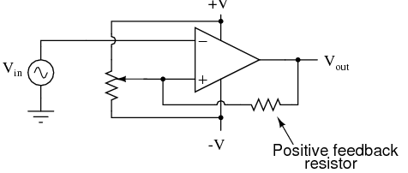

Fig 3: Vin from LDR feeds a simple comparator. Calculate and connect R1, R2 such that VT = 3.5V

R2

R1

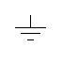

LDR



Rset

+5V

VT

0VV

0VV

Vin

Demonstrate your circuit operation with the LDR in steady state producing Vin ~ 3.5V. As Vin changes even slightly due to noisy ambient light, demonstrate what happens to Vout on the DSO trace.

**Part C: Noise-immune comparator with positive feedback (Schmitt trigger)**

To improve the stability of the circuit and guard against unwanted switching, we would like to define ‘upper’ and ‘lower’ threshold reference voltages [VTU ,VTL] such that as long as Vin is in between the band defined by the voltage levels VTU and VTL the output remains stable at either +Vmax or –Vmax­

As discussed in lecture 2, whether the output goes to +Vmax or –Vmax­ is determined by value of Vin just before it enters the ‘safe’ [VTU , VTL] band.

To accomplish this, consider making the connections shown in Fig 4:

Vin from LDR



Fig 4: Positive feedback through Rf stabilizes the circuit response

Rf

R2

R1



0VV

0VV

Calculate Rf such that VTL = 3V, VTU = 4V.  
*Hint: As discussed in the lecture, this is a straightforward calculation using superposition. Independent sources +V, -V, Vin are set to zero. VT is set by R1 and R2. v+ is a function of R1 , R2 , Rf ,Vout. Vout  can have two values +Vmax and –Vmax This gives an upper and lower band around VT  : VT + δv+ = VTU and VT - δv+ = VTL where we would like to set* |*δv+*| *= 0.5V*

Demonstrate your circuit operation with Vin from the LDR as before. The output should stay in a stable state (+Vmax or –Vmax) as long as Vin is in the [3V, 4V]band.

If noise level in Vin exceeds this band (for example by shining a light directly onto the LDR), Vout should switch state.