**Laboratory 5**

**A**: /4**B**: /6 **Tot:** /10

**Part A: Measurement of opamp imperfections: Vos**As discussed in the lecture, any opamp suffers from two sources of error *without an external input*. The first is an offset voltage caused by mismatched currents in the emitter legs of the two input transistors that make up the differential input pair. This is relatively easy to measure and compensate. Setup a simple feedback amplifier with a large gain of +1000. Connect *both* Vin and the unused opamp input to 0V using short *equal* lengths of wire. Use the measured output value to calculate *Vos*

Note: *Vos* is the offset voltage created at the *input* which is amplified by the gain of your amplifier

Compare the measured value with the specifications of typical *Vos* for LM741 in the datasheet.

**Circuit Diagram to measure Vos (with component values):**

Standard non-inverting feedback with gain of 1000: *Rf = 100kΩ, Rg = 100Ω*

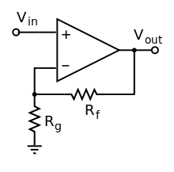

+V

-V (4)

1

5

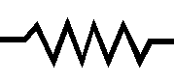

Measurement of *Vos _______________ Vos = 1 to 6 mV so output Vo should be ~ 1 to 6V*

Comparison with expected typical values from the LM741 datasheet:_______________

Use a potentiometer connected to the offset null pins 1 and 5 and pin 4 to balance the emitter leg currents of the two halves of the input differential pair (look at the datasheet for the connection details) Demonstrate that you can get rid of *Vos* in your opamp by fine-tuning the value of the potentiometer.  
*Hint: O(10 kΩ) potentiometer values are usually needed. Multi-turn potentiometers are notoriously sensitive to slight movements of the knob. Make sure that you measure the potentiometer setting after you have fine-tuned the value to null Vos. Set it aside so that you don’t bump it accidentally and change the settings for Part B of today’s experiment.*

**Part B: Measurement of opamp imperfections: Ibias**The second source of error in an opamp at DC is the mismatch between the bias currents into the bases of the two input transistors. This is called *Ibias.* It is typically:

* Of very small value (μA or less)
* Can be different for the two inputs of the opamp, in general *Ibias+ ≠ Ibias-*
* Hence, somewhat harder to measure.

Setup a feedback circuit to measure *Ibias* for the LM741 with the assumption that *Vos* has been compensated accurately using the offset null as in Part A

*Hints:  
1. Putting a capacitor in the feedback loop integrates any current present at the input with Vin = 0  
2. A capacitor’s I-V relation gives you V = 1/C\**∫*I dt,* or more usefully: *I = C*dV/dt  
3.* After integrating *Ibias,Vout* is limited to the saturation values±*Vsat* The important point is to determine the *slope* *dV/dt  
4. You must measure Ibias+and Ibias- separately:* the circuit connections to measure each are similar. When measuring one, the other terminal must be grounded to 0V.

**Circuit Diagram to measure Ibias (with component values):**

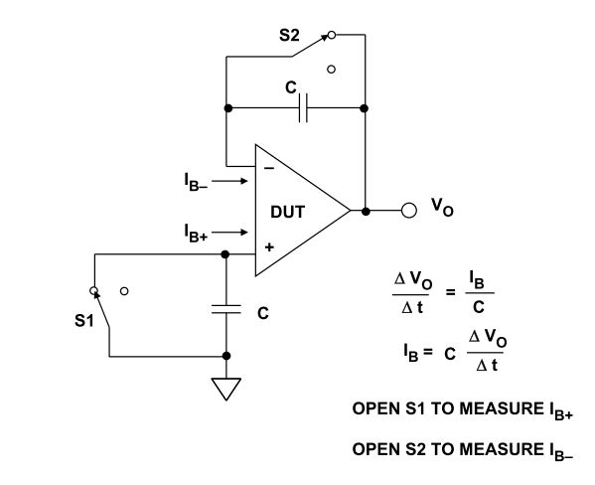*Converting to time domain: 1/ω→∫ and ω→ d/dt*

*For Ib- : + terminal is grounded.   
vo­ =A(0 – v-) v- = Ib- * 1/jωC   
so vo will saturate to +/- Vsat  depending on sign of Ib-  
 Ib- = C*dv0/dt i.e. measure the slope of vo as it (linearly rises towards saturation.*

*For Ib+ :   
S2 closed and opamp functions as unity gain follower.  
 vo = v+ = Ib+ * 1/jωC and Ib+ = C*dvo/dt*

*Note: Must measure vo not v+ or v- ! Ib+ Ib- are nA level currents. So putting the DSO probe at v+ or v- loads the ‘source’ of Ib+/- with the DSO scope impedance in parallel with C. Above equations will need to be adjusted to account for (ZDSO* || *C)  
Some students decided to measure Ib+ by simply interchanging connections to – and + terminals of the opamp. This is not correct. By doing so you are making a positivefeedback circuit and driving vo quickly to saturation which forces the opamp output stage to drive a much larger output current Io. So current in the 1/jωCimpedance is not just Ib+  Ib+ + Io of which the latter is unknown.*

Measurement of *Ibias ___________________________ ~1nAtypical for LM741*

Comparison with expected typical values from the LM741 datasheet:_______________