**Laboratory 7**

**A**: /4 **B**: /3 **C**: /6 **D:**  /2 **Tot:**  /15

**Power transfer and impedance matching**

**Part A: DC Power transfer**

Consider the circuit shown in Fig 1. It has an *ideal* DC voltage source *VS*. A practical voltage source will always have some internal resistance, here denoted by *RS.*  The object in the dotted box containing a voltage source *VS* with an internal resistance *RS* supplying a current *I* is our model of a practical power source. *RL* is the load resistance to which the power is supplied.

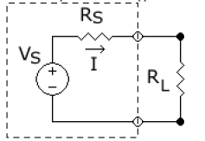

Fig 1

source

Using Kirchoff’s laws, work out the following questions

**Q1:** What is the *total* power produced by the source? *PS*|Itotal ?

*VSI = VS2/(RS+RL)*

**Q2**: What is the power dissipated *inside* the source?

/1

/0.5

/0.5

/0.5

/0.5

/0.5

/0.5

*I2RS*

**Q3:** What is the power dissipated in the load?

*I2RL*

**Q4:** Since you can specify the load *RL* in your design (*RS*  is a fixed parameter of the power supply) what is value to which you must set *RL* so as to ensure *maximum* transfer of power from source to load?

*RS=RL*

**Q5:** Define efficiency of power transfer as the ratio of power dissipated in the load, to the total power produced by the source *η = PL / PS|total* What is the efficiency of power transfer in Fig 1?

*I2RL/VSI = I/VS RL = RL/(RS+RL) = 1/(1+RS/RL)*

**Q6:** What is the efficiency in the case of *maximum* power transfer that you have worked out in Q4?

*0.5 for RS = RL*

[Note that this intrinsic limit on the efficiency of power transfer from a DC source is the reason that power is transferred as AC from the source to your wall socket]

**Q7:** Consider the limiting case for efficiency of power transfer worked out in Q5 above:  
Keeping *RS* fixed, For what value of *RL* would you get *η = 1?  
Think carefully!* Although the efficiency is 1, is any power actually transferred in this case?(what would be the value of the current *I* in the circuit?)  
 *RL = infinite, power transfer = 1 theoretically. But no current delivered to the load!*

**Part B: AC power transfer**

For most circuits in analog electronics, our goal is to transfer time-varying electrical signals from one part of the circuit to another without introducing distortions. The load of each part of the circuit must be modeled using complex impedances which take into account the frequency (hence time) dependence of the equivalent resistance presented by that part. Distortions in signal transfer typically occur in the form of *reflections*: A time-varying electronic signal travelling on a cable is an electromagnetic wave – when it reaches its destination (the load) some fraction of it can be reflected back to the source.  
Fig 2 gives a simple analogy from physics:

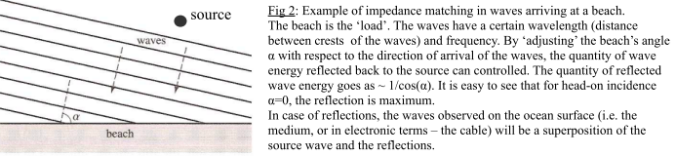

**Experiment to measure reflections in 1 meter coaxial cable**

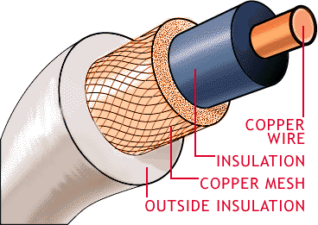Our objective is to measure reflections (an electromagnetic wave) in a coaxial cable. The length of the cable is one of the parameters in our measurement.

Fig 3: cutaway sectional view of a coaxial cable.

Instructor’s note: Students often carry over the internal RS   
source resistance into the AC analysis – this is unnecessary  
and confusing. ZS is the net impedance looking ‘into’ the  
source and VS is the voltage provided at its two terminals.  
In fact ZS does not enter into the calculation below.  
  
Refer to Fig 4, where the cable of impedance Z0 is explicitly put in as an intermediate circuit block (DUT) between the source and load  
**Definitions:**

a) Reflection is defined as the signal the source produces in the DUT’s impedance *minus* the signal the source produces in the final load, if the DUT were absent.

b) The reflection coefficient is the *ratio* of the reflection to the total signal produced by the source.

**QB1**: Given a source of impedance *ZS ­*and a cable of impedance *Z0* connecting to a load of impedance *ZL as* shown in Fig 4  
**Calculate the reflection and the reflection coefficient that the cable impedance *Z0* introduces into the circuit.**

*Source*

*ZS (Signal VS)*

*Cable*

*Z0*  (DUT)

*Load*

*ZL*

Fig 4

The right pointing arrows represent signal transmission from source to load, and the left pointing arrows represent the reflected signal. You are required to consider the cable *Z0* as the ‘device-under-test’.  
*Hint: Consider Z0 as driven by a superposition of two sources: Zs (original source) and reflected signal from ZL*

A: Reflection –

B: Reflection coefficient -

/2

/1

Setup an experiment that looks logically equivalent to the one in Fig 4.   
The source is a function generator set to square wave at 1 MHz, 10% duty cycle (it will become clear why we are using such a high frequency and small duty cycle for this experiment)  
> The source impedance *ZS* is noted on the front panel of the function generator, take note of it.  
> We will use a simple resistive load ZL of different values in the following measurements.

**QB2: Draw your detailed circuit diagram translating the logic of Fig 4 into an experimental setup.   
Note especially the points where you will connect your DSO probe.***Hint: Only one channel of the DSO is needed to perform the measurement: Your objective is to measure the signal and reflection - it is necessary to probe this at only one location in Fig 4.Decide which is the best location considering the fact that you want the source signal and the reflection to be well separated in time so that they can be resolved on the DSO trace.*

**Part C: Measurement of reflections.**   
Measure the length of the coaxial cable given to you. Connect one end of the cable (core + shield) to the function generator. The load ZL is connected between the core + shield at the other end.  
Draw a detailed diagram of the observed DSO trace under the following conditions. Note carefully the time positions of features in the signal traces observed.  
Explain each trace based on your calculation of the reflection co-efficient in QB1 above:

**1) ZL = Infinite (core + shield left unconnected)**

/0 *(Advice is free!)*

/2

/2

/2

**2) ZL = 0 (core + shield short-circuit)**

**3) ZL = 51Ω (resistor of 51Ω connected between core + shield)**

What would be your recommendation to a novice designer in choosing the cable impedance *Z0* so as to minimize unwanted reflections?

**Part D: Speed of light in coaxial cable**In your circuit setup, you will likely see reflections of the square wave propagating back and forth in the cable. Each reflection travels at the effective speed of light in the dielectric medium of the cable. You know the length of cable. Putting the two values together, obtain the speed of light in your co-axial cable.  
*Note: the speed of light is 3x108m/s in vacuum. It is different depending on the properties and geometry of dielectric medium in the cable you are testing. Cables used for RF signal transmission have standardized dielectric media with specific values of the speed of propagation – these cables are labelled as RG-59, RG-62, RG-64 etc.*

/2

*Further work: Note in particular the DSO trace for the case where ZL = infinite* i.e. *there is an open circuit between the core and shield of the cable*. *The signal is reflected by the open-circuit load and attenuated by the resistive part of Z0. You can measure the time lapse between the signal and its reflection. By testing a known good cable with good termination, you can determine the speed of transmission in the cable. Consider the case when you have an arbitrarily long cable (say 3km between IIT-B power plant and H-12) and there is a break in the cable somewhere due to wildlife attack (aka hungry mice). It is practically difficult to dig up the entire length of cable to determine the location of the break by visual inspection. Using the ‘time-domain reflection’ technique worked out above, you can determine the location of the open-circuit break (or short-circuit) by merely transmitting an RF signal from the source and observing the time it takes for reflections to arrive back.*