**Laboratory 2 – Active electronic elements**

**Introduction:**

**Review of Lab 1:**  Recall that in Lab 1, we looked at the difference between voltage and current sources.

1. We used passive elements – two resistors in series that act as a voltage divider to test the characteristics of the source.
2. The key conclusions of the assignment were
3. It is fairly easy to make a nearly ideal voltage source (fixed *V* for any value of *I* drawn by load) – a battery is a common example.
4. It is hard to make a good current source (fixed *I* for any value of *V* or load resistance *R*). A voltage source with a very large *R* in series with it, *sort of* acts like a non-ideal current source.

**Today:** In Lab 2, we will introduce the simplest *active* electronic element – a diode. The electronic symbol for a diode is:

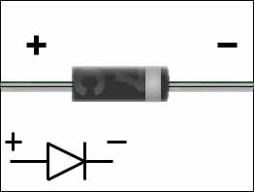

Anode Cathode the physical device looks like:

Think of a diode as a one-way conductor, it only conducts current in one direction from its anode to its cathode once the potential at the anode is ~ 0.7 V above the cathode. The exact value of this potential varies slightly depending on the types of diodes.

When a diode is conducting, it is said to be ‘ON’, when it is not conducting, it is said to be ‘OFF’

*In all the following exercises, please take careful note of the polarity of the diodes (+and - terminals) when connecting them in your circuits.*

/1+1+1

/2

Ex 1

Ex 2

/1

/1

/1

/3

/4

Ex 3.A Ex 3.B Ex 3.C Ex 4.A Ex 4.B

/15

Total

**Exercise 1: Diode clamp**

Connect up the circuit shown in Fig 1. Use the function generator to supply *Vin*.   
Vary the amplitude of the input voltage in the range ~ 0 to 2 volts.  
Observe *Vin*and *Vout* on the DSO.

Draw the observed *Vin* and*V­out* voltage waveforms as a function of time.

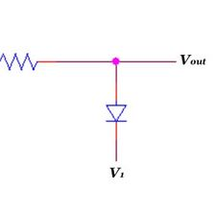

Fig 1

R=1K

*Vin*

*Vout*

D1

0V ‘GND’

**Q.A)** What happens to diode D1 conduction for *Vin > ~0.7V? __________________________*

**Q. B)** What is p*ath* of *Iin* for *Vin > 0.7V? ___________________________________________*

**Q. C)** *D1* has a limit of ~ 10 mA on the current which it can safely pass when forward biased. What happens if *Iin* exceeds that value?

*Discussion Such diode “clamps” are used for voltage protection of inputs on most electronic equipment. In particular, a diode clamp can protect the input of a device from electrostatic potential discharge – friction & dry weather produces electrostatic potential on your fingers which is positive*

**Exercise 2: Diode Limiter**

Connect up the circuit shown in Fig 2

Measure and draw the input and output voltage waveforms *Vin ,Vout* as a function of time.   
Vary the amplitude of the input signal in a small range from 0 to 2V.



Fig 2

R=1K

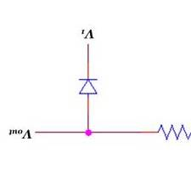

*Vin*

*Vout*

D1

D2

0V ‘GND’

**Q)** What happens to D1 and D2 conduction state when *Vin* exceeds ~ 0.7 V in either positive or negative sign?

A)__*Vin >+0.7V*: ________________________________________________________________

B)__ *Vin< -0.7V*: ________________________________________________________________

*Discussion: Why are diode limiters useful? When amplifying small signals with a large gain (something we will look at in the later labs), it is necessary to ensure that the input signal remains within limits at both signs – in electronic terms to limit the ‘swing’ of the signal. For example if an amplifier operates from +/- 100V power supplies, it can produce a maximum output voltage of +/-100V. If it has a gain of 200, the input signal must stay within a range of +/- 0.5V in order for the output not to saturate.*

**Exercise 3:**

Connect up the circuit shown in Fig 3 and observe the input signal (from the function generator, sine wave ~ 50 Hz, 5V amplitude) and output signal on two channels of your DSO.

**Q.A)** Draw a measured the input & output voltages as a function of time. Points 1-0 are measured on channel 1 of the DSO, points 2-0 are measured on channel 2

**Q.B)** How do your observations change if the input signal amplitude *V1* is less than ~ 0.7V?

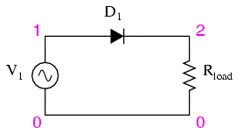

Fig 3

1 kΩ

**Q.C)** Indicate on your waveform diagram when D1 is conducting, and when it is not.

**Exercise 4:**

Extend your circuit earlier so that it now has four diodes as shown in Fig 4. As before, use the function generator to provide the input sine waveform. The circuit in Fig 4 should look familiar from previous studies. *Vin*  is provided across points labeled 1 & 2, *Vout* is measured across 3 & 4

**Q.A)** Observe the waveforms under the following conditions carefully, and draw your measurements below:

**Q.A1)** Only *Vin* is measured across 1 & 2

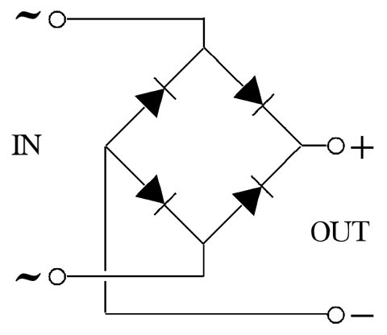

Fig 4

D1

D2

D3

D4



OUT

1

2

3

4

1 kΩ

*Vout*

*Vin*

**Q.A2)** Only *Vout* is measured across 3 & 4

**Q.A3)***Vin* and *Vout* are measured at the same time on two channels of the DSO

**Q.B)** Explain the circuit behavior you observe by ticking the appropriate options and concluding:

Positive half cycle of *Vin* : D1 = ON/OFF D2 = ON/OFF D3 = ON/OFF D4 = ON/OFF

Negative half cycle of *Vin* : D1 = ON/OFF D2 = ON/OFF D3 = ON/OFF D4 = ON/OFF

In positive half cycle, circuit behaves as a:_____________________________

In negative half cycle, circuit behaves as a:_____________________________ *Hint1*: Recall your work in Exercise 1  
*Hint2*: One end of the DSO probe is internally grounded – i.e. fixed to earth reference 0V.

*Hint2*:what happens to D4 if points 2 and 4 are at ground voltage?