**Laboratory Assignment 4: IC555 and its applications**

Today’s assignment is based on the IC 555. This is perhaps the most commonly used IC among digital circuits for general purpose pulse generation. Fig 1 shows the pinout of the 8-pin IC and Table 1 below lists the detailed function of each pin.

**Introduction:**

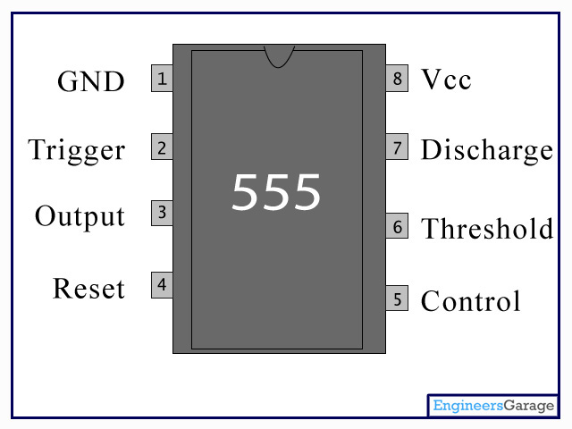

Fig 1: Pinout of IC555 timer IC

Table 1: IC 555 **Pin Description:**

|  |  |  |
| --- | --- | --- |
| **Pin No** | **Function** | **Name** |
| 1 | Ground (0V) | Ground |
| 2 | **Voltage below 1/3 Vcc to trigger the pulse** | Trigger |
| 3 | **Output Pulse** | Output |
| 4 | Active low; interrupts the timing interval at Output | Reset |
| 5 | **Provides access to the internal voltage divider; default 2/3 Vcc** | Control Voltage |
| 6 | **Output pulse ends when the voltage is greater than Control** | Threshold |
| 7 | Open collector output; to discharge the capacitor | Discharge |
| 8 | Supply voltage; 5V (4.5V - 16 V) | Vcc |

The functional block diagram of what’s inside an IC555 is given below as Fig 2. The bulk of the

‘decision making’ logic is inside the block labeled ‘Control F/F’

The important features of an IC 555’s behavior are:

1. The output is a ‘pulse’ output switching between 0 and Vcc – the width and frequency of pulses can be controlled using an external resistor and capacitor
2. When Trigger voltage (pin 2) falls *below* 1/3 Vcc the output goes high.
3. The voltage at the Threshold pin 6 controls when the output goes low. Nominally the threshold is set at 2/3 Vcc – when threshold voltage at pin 6 increases *above* 2/3 Vcc, output goes low
4. Control voltage at pin 5 can be used to change the value of the desired threshold. It’s OK to leave it disconnected – in that case the threshold defaults to 2/3 Vcc
5. The Reset pin 4 is normally held high – applying low voltage to Reset immediately sets the output low.

As noted in the functional diagram, the discharge pin is internally connected to GND through a control transistor T1.

Based on the above logic, the control F/F turns T1 off (setting output high), or turns T1 on (discharging the capacitor to pin 1 GND through T1)

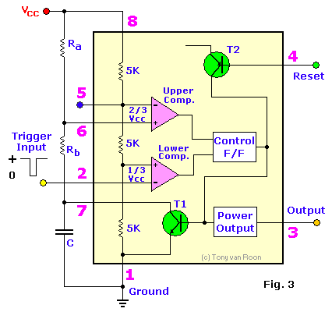

Fig 2: Functional blocks in IC555

1: 3mks

2: 4mks

3: 8mks

/15

**Exercise 1: Use an IC-555 as a bistable circuit (30 min)**

Set up the IC555 as a simple bistable circuit driven by two momentary switches. The conditions governing the behavior of a bistable circuit are:

1. Normally the output is in logic 0 level (0V)
2. One switch acts as the start (trigger): when it is pressed, the output jumps up to logic 1.
3. The second switch acts as the stop: when it is pressed, the output comes back to logic 0.

*Hint: Look at the functional diagram of the IC555 carefully on page 1. To implement a bistable circuit, you need to only concern yourself with pins 6 and 2 (and some current limiting resistors). Note carefully that pin 2 works as active-low and pin 6 as active high.*

Draw your circuit diagram here and build it on the breadboard. Be neat in your circuit connections, you will need it for the next exercise!

Ex. 1: 3 mks

**Exercise 2: Use an IC-555 as a monostable pulse generator (40 min)**

Suppose you would like to use the IC555 to detect the arrival of the *first* trigger pulse in a series of pulses and ignore the rest. The desired timing diagram of the input (trigger) and output behavior is given below in Fig E.2. Draw a circuit adding the necessary resistor and capacitor to an IC-555 that implements this behavior.

An example application of such a circuit would be to ‘debounce’ a springy push-button switch. When you push the button, it generates a sequence of pulses due to the spring bouncing and making contact multiple times. You would like to detect just the first pulse.

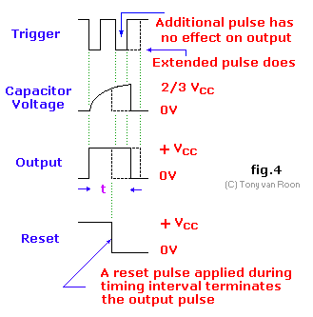

Fig E.2: Desired behavior of an IC555 circuit with associated R & C. The pulse width *t* is determined by R and C

Ex. 2: 4 mks

*Hint: You need to build upon the circuit design made in Exercise 1. The trigger is provided externally, but the reset signal is generated by the circuit itself after a fixed time. A signal requiring the generation of a signal after a fixed time typically requires a capacitor charging up.*Calculate the required R and C values so that the circuit has an ‘ignore’ time of 1 second.

You can demonstrate the behavior of your circuit by explicitly using the momentary push-button switch as trigger. Press the trigger twice quickly (within 1 second) and observe the trigger and output trace on the DSO with a long timebase.

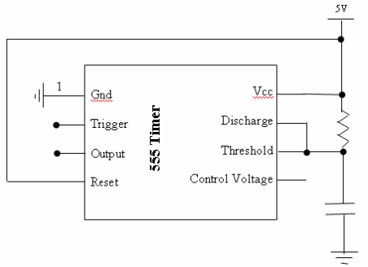

R

C

*t = 1.1 RC*

*C = 1μF nonpolar*

*R = 1 MΩ*

**Exercise 3: Use an IC-555 as astable multivibrator (80 min)**

Now extend the design of Exercise 1 & 2 so that your circuit produces a string of output pulses on its own without any external trigger. The frequency of the pulses and the duty cycle must be controlled by the value of the resistors and capacitor you use. Here duty cycle is defined as (*thigh*)/( *thigh + tlow*) The desired output is indicated in Fig E.2

*freq = 1/( thigh + tlow) duty cycle = thigh/(thigh+tlow)*

*thigh tlow*

Fig E.2: Desired output of an astable multivibrator

Ex. 2: 4+4 mks

Calculate how the frequency and duty cycle depends on the values of Ra , Rb and C.   
Build your circuit and demonstrate its operation with duty cycle values of 60%, 70%, 80%

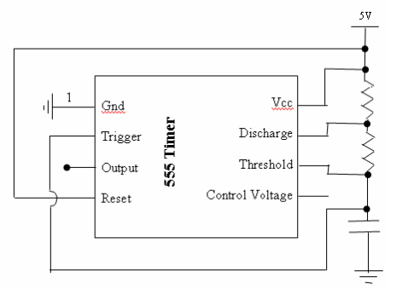

R1

R2

C

*thigh = 0.693 C (R1+R2)*

*tlow  = 0.693 C R2*

*ok if the solution omits factor of 0.693*

*duty cycle = (R1 + R2) / (R1 + 2R2)*

*frequency = 1 / (R1 + 2R2)*

*Note that duty cycle cannot be less than 50% with the above circuit.*

*R1 = 0 shorts VCC to discharge pin*

: