**EP317 – Digital Electronics: Lab. Assignment 5 - DAC**

**Procedure:**

This assignment has a single Exercise with several Questions. Work out the solution to the design problem first on paper and implement it on a breadboard. You are required to submit the complete question and answer sheet with your design and answers filled in where asked, and show your working circuit to a TA.

**Designing a Digital-to-Analog Converter:**

**Introduction:**

A Digital-to-Analog Converter (DAC) converts a digital input code into an analog output voltage. It takes a digital input signal as an n-bit number represented by TTL logic levels, and produces a proportional analog output voltage in a fixed range. For example, a 4-bit parallel DAC would have four input lines, and have an input range corresponding to (0000-1111)   
(0-15). If we fix the analog output voltage range of this DAC to be 0 V to 4 V, then any input code between 0000 and 1111 would give a proportionally intermediate value of output voltage, as shown in Fig. 1. The larger, the number of bits, the smaller the ‘step size’ in Fig 1 – i.e. the response of the DAC suffers from lesser *quantization* error as you increase the number of bits.

Vout

0000 0001 ………………………………………….1111 Fig 1

0 volt

4 volt

Note: Quantization error

does not let output reach full scale

There are many different types of DAC’s – the designs have different trade-offs between linearity, speed of conversion, output drive capability etc. We will design and analyze a very basic DAC.

**Problem Statement:**

Design a 4-bit DAC using the following parameters:

* It must have only passive components. Note that passive components → R,L,C. Of these, R is the only *linear* passive – and linearity is a desirable property of a DAC as seen in Fig 1
* The analog voltage range of the DAC must be set externally.

Here are a few tips to get you started – start with trying to make a 1 bit DAC using the above constraints as shown in the following diagram:

2RR

R

R

Bit 0

Vout

Vref

**1:** What are the components you would put in the blocks marked with a ‘?’, and what are their values,

*relative* to each other? Do the actual values of the components matter?

/1

R, R and 2R as shown

**2:** Work out the equation that determines Vout as a function of Bit0, Vref and the component values you are

/1

using for the 1-bit DAC.

Vout = (1/2 B0) Vref

**3.1:** How would you set the maximum value of the DAC output?

/1

Adjust Vref

**3.2:** How would you set the minimum value of the DAC output?

/1

Instead of GND, use -Vref

**4:** Point out a flaw in the design with respect to the dependence of Vout on the internal characteristics

of the circuit and the nature of the load. *[For an ideal design circuit, the output should be a purely logical  
 (mathematical) function implemented in the circuit, irrespective of the circuit components and the nature of  
 the connected load]* Does this circuit behave like an ‘ideal’ design? If not, why not?  
 Hint: What is the output impedance of this circuit? What restrictions does it place it on the load?

/2

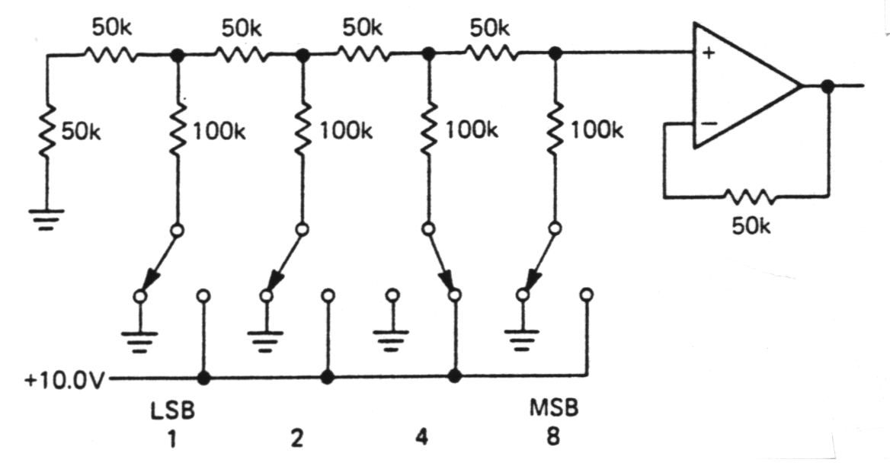Output impedance = R; Load can only get 1/2 the current that Vref can supply

**5:** Now extend your design from a single bit DAC into a 4-bit DAC. Draw the DAC design below with the

appropriate component values filled in, and work out the full equation for the 4-bit DAC as in Question 2

/7

*Hint:* You are only allowed to use two values of components.

Vout = (1/2 B3 + 1/4 B2 + 1/8 B1 + 1/16 B0) Vref *Note that there will always be ( 1/2n+1) LSB error for*

*an n-bit DAC*

**6:** Wire up the DAC on a breadboard using any suitable component values. Demonstrate its operation to a

/2

TA with three or four suitable inputs from the 0000-1111 range. Use wires connected to Vmin or Vref as

switches. Be neat! It should be possible for us to understand your circuit design by simple inspection.

Leave the circuit connected on your breadboard for future use!

Total=15